Installing node-red and implementing OPC UA nodes.
Description:
After reading the node-red general guide and the windows installation guide, node-red was installed on windows 11 and additional OPC-related nodes were installed as well.
Regardless of the platform, the outcome is a node-red instance running and accessible through http://127.0.0.1:1880/
From this point forward we assume to be working on Windows 11:

Setting up node-red to work in project mode
Open your settings.js file
Inside your gateway project, find:
~/.node-red/settings.js

Enable Projects Mode in settings.js
Open the file and look for this block:
//editorTheme: {
// projects: {
// enabled: false
// }
//},
You must uncomment and set enabled to true:

editorTheme: {
projects: {
enabled: true,
workflow: {
mode: "manual" // recommended for Git workflows
}
}
},
Stop Node-RED
If node-red was already running, go to the command line from when you started node-red and do Ctrl+C to stop it
Start it again from the command line:
> node-red

Go to Node-RED UI
Now go to:
http://localhost:1880
Open Menu → Projects
You will now see:

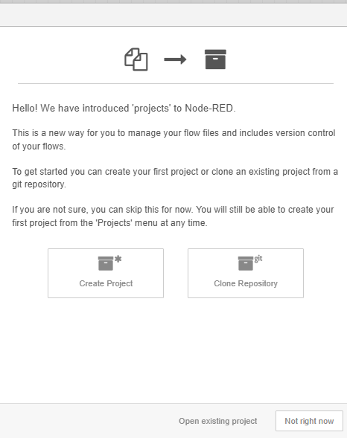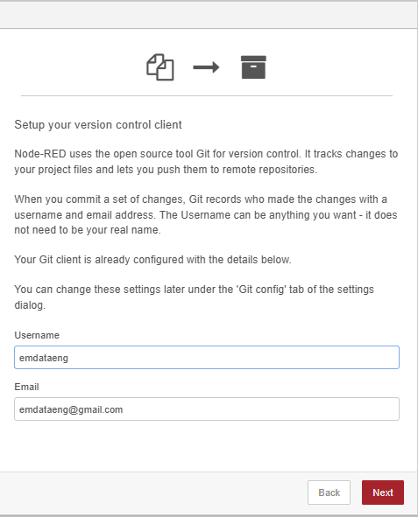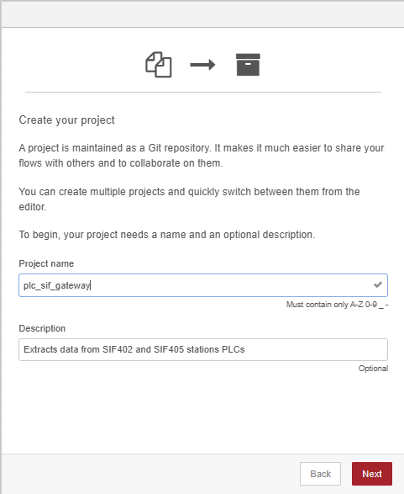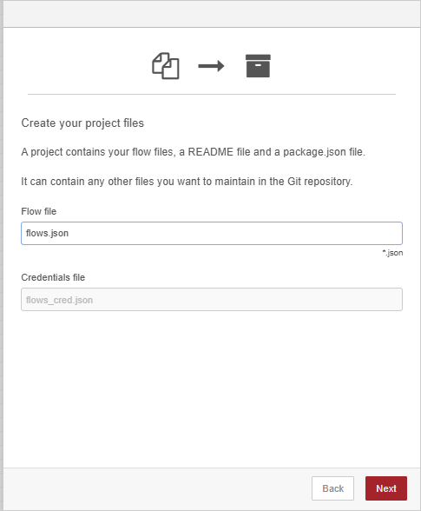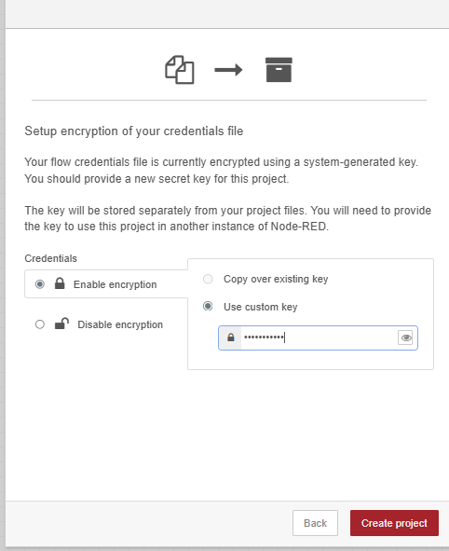

Close Node-red again.

Tell Node-RED to use the new folder as the working directory
Node-RED runs from a “user directory”.
On Windows, the default is:
C:\Users\<you>\.node-red
To point Node-RED to your project folder, start it like this:
node-red -u D:\Code\XR\unity-hololens-industrial-data\services\plc_sif_gateway

Where:
-u <folder> = “Use this folder as the Node-RED user directory”.
This MUST be the folder containing:

flows.json
flows_cred.json
settings.js
package.json

Confirm Node-RED loads the project correctly
Visit:
http://localhost:1880
You should see:
Your flows
Your project name in the top right
Git controls (if enabled)

You might get a message saying that some nodes are not installed, in that case you need to reinstall the missing nodes, like opc-ua again.
Another message could say that the flows credentials were not found, that could happen if you set up a password for encrypting credentials when you enabled the project mode on the previous step and for some reason it does not encounter the .sshkeys folder now. Don’t’ worrty about it, it can be re-created.

Important:
Every time you want to start node-red now, you must indicate the folder where the projects file are saved, ex:
node-red -u D:\Code\XR\unity-hololens-industrial-data\services\plc_sif_gateway

API Endpoint for SIF 402
http://localhost:1880/mes/402_latest

JSON response:
{
"station": {
"id": "SIF-402",
"status": "Running",
"recipe": "StandardMix_v2.3",
"timestamp": "2025-12-14T10:22:29.190Z",
"runningTime": 1042494,
"current": 0.439999997615814,
"hopper1": {
"present": true,
"minPellets": true
},
"hopper2": {
"present": true,
"minPellets": true
},
"hopper3": {
"present": true,
"minPellets": true
}
},
"alarms": [
{
"id": "station_alarm",
"severity": "info",
"message": "Station has none alarms",
"timestamp": "2025-12-14T10:22:29.184Z"
}
]
}

API Endpoint for SIF 405
http://localhost:1880/feeders
JSON response:

"feeders": [
{
"feeder": 1,
"caps": 8,
"type": 1,
"simulated": false
},
{
"feeder": 2,
"caps": 4,
"type": 2,
"simulated": false
}
]
}

